**UID exercise 2**

**Memory recall task**

* This experiment includes a memory test where the user has to remember certain icons displayed after starting the game.
* The user will then have to select the icons that they remember in the next page and submit the items.
* The completion feedback is given in the last page.
* The user can then click on the last slide once again to start back the game from the beginning.

**Memory**

* Memory is one of the most important topics under User interface design. The user should feel free to explore the application while knowing what each and every icon will do at the very least.
* This task helps the user to remember the icons very well and navigate to the respective page the user wants to do so.

The start page

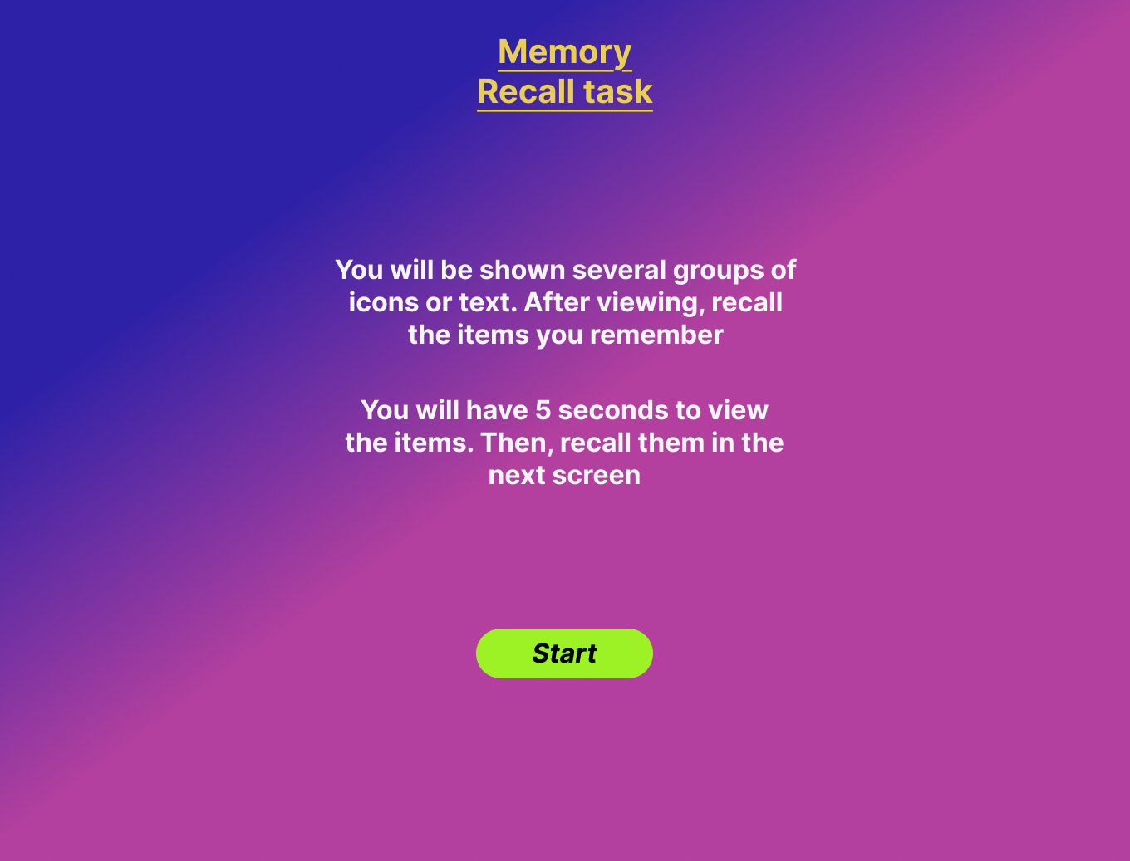

Icons display page  
  
  


Icons submission page  
  
  
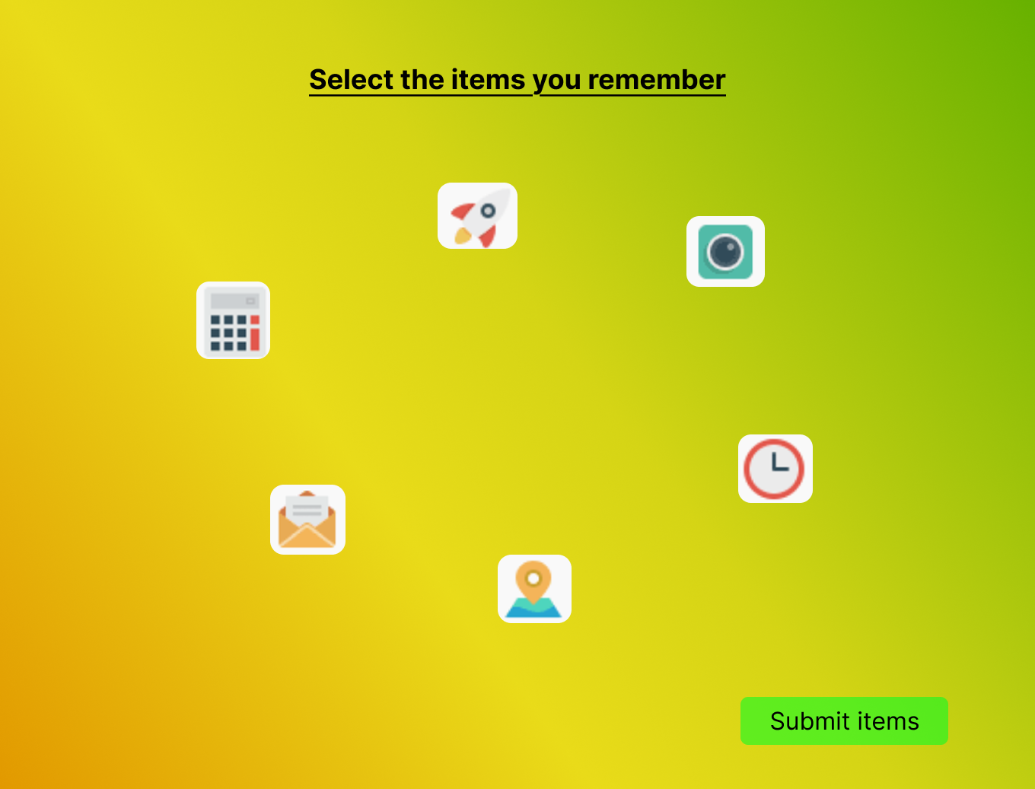

Feedback page

